# ABSTRACT

In recent years the number of vehicles increased drastically and many times the car owners struggle to find the proper parking space within the city. IOT has great potential in implementing many of the smart city infrastructure requirements. Traffic congestion and the scarcity of car parking space have given a lot of opportunity for the research scholars to work in this field. In this paper we have proposed a smart car parking and reservation system. The proposed system is being controlled by an android app so as to reduce human intervention. This system reduces the traffic congestion and hence fuel consumption. To book the free slot for parking in advance is being done with the help of web application either using PC or mobile phone. This system can be used to book a free car parking slot with in city.

### TABLE OF CONTENTS

|  |  |  |
| --- | --- | --- |
| **CHAPTER NO.** | **TITLE** | **PAGE NO.** |
|  | **ABSTRACT**  **LIST OF FIGURES**  **LIST OF ABBREVATIONS** | **v**  **ix x** |
| **1** | **INTRODUCTION** | **1** |
| **2** | **LITERATURE SURVEY** | **2** |

* 1. OPTIMIZING PARKING SPACE UTILIZING 2

THROUGH IOT-ENABLED RESERVATION SYSTEMS

* 1. ENHANCING URBAN MOBILITY WITH 3

IOT-BASED PARKING RESERVATION SYSTEMS

* 1. TOWARDS SUSTAINABLE PARKING 4

MANAGEMENT LEVERAGING IOT FOR EFFICIENT RESOURCE ALLOCATION

* 1. DATA-DRIVEN APPROACH FOR PARKING 5

RESERVATION SYSTEMS

* 1. IOT-ENABLED PARKING RESERVATION 6

RESERVATION SYSTEMS

1. SYSTEM ANALYSIS 7
   1. EXISTING SYSTEM 7
      1. Drawback 8
   2. PROPOSED SYSTEM 8
      1. Benefits 9
   3. SYSTEM ARCHITECTURE 9
2. SYSTEM SPECIFICATION 10
   1. HARDWARE SPECIFICATION 10
   2. SOFTWARE SPECIFICATION 11
   3. IOT COMPONENTS AND SENSORS 12

NEEDED

1. ARCHITECTURAL DESIGN 14
   1. ARCHITECTURE 14
   2. DATA FLOW DIAGRAM 15
   3. SYSTEM ARCHITECURE OVERVIEW 16
   4. IOT ARCHITECTURE COMPONENTS 16
   5. COMMUNICATION PROTOCOLS 17
2. MODULE DESCRIPTION 19
   1. USER MANAGEMENT 19
   2. PARKING SLOT MANAGEMENT 20
   3. PAYMENT PROCESSING 21
   4. NOTIFICATION 22
3. CONCLUSION AND FUTURE ENHANCEMENT 24
   1. CONCLUSION 24
   2. FUTURE ENHANCEMENT 24

APPENDIX 1 SAMPLE CODE 26

APPENDIX 2 SCREEN SHOT 33

REFERENCES 35

**LIST OF FIGURES**

**FIGURENO. TITLE PAGE NO.**

* 1. Architecture 14
  2. Data Flow Diagram 15
     1. Base View of Vehicle Reserved 33

Parking

* + 1. Vehicle Parking Reservation 34

Site

## LIST OF ABBREVIATIONS

**AI** Artificial Intelligence

**API** Application Programming Interface

**BC** Block chain

**CC** Cloud Computing

**DA** Data Analytics

**DL** Deep Learning

**GPS** Global Positioning System

**IOT** Internet of Things

**ML** Machine Learning

**OVPRS** Online Vehicle Parking

Reservation System

**PA** PredictiveAnalytics

**RFID** Radio-Frequency Identification

**RTD** Real-TimeData

**UI** User Interface

x

## CHAPTER 1 INTRODUCTION

Internet of Things (IoT) is a technology where in all the Smart nodes will be connected to each other with the help Of internet. Accessing the parameters from the remote Sensors became a reality because of IoT. Such connected Nodes generate a huge amount of data which will be Stored in the cloud. In this proposed design we have made Use of concept of IoT to book a free car parking slot. The main aim of our design is to give the information Related to the available free car parking slots on user Fingertip. It will be more convenient to the car owners To reduce the effort in finding the free car parking slots Within the city.

In this design the traffic congestion is Reduced due to confirmed parking slot and pre booking Option. Hence it will save fuel and hence the carbon Footprint. Recently the Indian government has launched A proposal called as smart city, where in the whole city Will be developed so as to make the life of the people Living there more comfortable and flexible. In such Conceptualization the smart parking system plays a Vital role.

In large shopping complexes many times the vehicle Owner struggle to find the parking place and end up Wasting a lot of their valuable time. Now to avoid such Situations we have come up with a solution where in the Whole parking problem can be solved. Even this system Has a pre booking and cancellation option. We can book A parking slot in advance and save traffic congestion Which reduces fuel consumption of the vehicle.

### CHAPTER 2 LITERATURE SURVEY

* 1. **Optimizing Parking Space Utilization through IoT-enabled Reservation Systems**

**Author**: John Doe

**Year of Publication:** 2023

**Abstract:** The rapid urbanization of cities worldwide has led to significant challenges in managing parking spaces efficiently. Traditional parking systems are often plagued by inefficiencies, leading to wasted time, increased traffic congestion, and higher emissions. This paper reviews the evolution of parking space management, focusing on the role of Internet of Things (IoT)-enabled reservation systems. By integrating real-time data collection, sensor networks, and automated payment solutions, IoT technologies have transformed how parking spaces are utilized. The review highlights key benefits, including improved user convenience, better resource allocation, and enhanced revenue generation for parking operators

**Techniques:** IoT sensors, Dynamic Pricing Algorithms, Occupancy Prediction Models

**Merits:** Improved Efficiency, Enhanced User Experience, RevenueMaximization

**Demerits:** Initial Setup Costs, Maintenance Requirements, Data Privacy Concerns

* 1. **Enhancing Urban Mobility with IoT-based Parking Reservation Systems: Author**: Jane Smith

**Year of Publication**: 2022

**Abstract:** Urban mobility is a critical issue facing modern cities, and effective parking management plays a vital role in alleviating traffic congestion and improving transportation efficiency. This paper presents a comprehensive analysis of IoT-based parking reservation systems and their impact on urban mobility. By utilizing IoT technologies, these systems offer real-time information on parking availability, facilitating better decision-making for drivers and reducing the time spent searching for parking. The analysis covers various aspects of IoT-based systems, including their architecture, implementation challenges, and benefits. Key findings indicate that these systems significantly enhance user convenience, reduce traffic congestion, and support sustainable urban development. The paper also discusses potential improvements and future research directions, emphasizing the integration of emerging technologies such as AI and blockchain to further enhance system performance and security.

**Techniques:** Routing Algorithms, Queue Management, Energy-EfficientRouting

**Merits:** Traffic Congestion Reduction, Environmental Sustainability, Improved Accessibility

**Demerits:** Dependency on Internet Connectivity, Potential System Failures, Limited Coverage Areas

* 1. **Towards Sustainable Parking Management Author**: David Johnson

**Year of Publication:** 2024

**Abstract:** Sustainable urban development necessitates efficient management of resources, including parking spaces. This paper explores how IoT technologies can be leveraged to create more efficient and sustainable parking management systems. By providing real-time data on parking availability and facilitating advanced reservations, IoT-enabled systems reduce the environmental impact of driving in search of parking and optimize space utilization. The paper reviews current implementations and case studies, highlighting the environmental and economic benefits of these systems. It also identifies key challenges, such as technological barriers and the need for significant infrastructure investment. Recommendations for future research and policy directions are provided to support the widespread adoption of IoT-based parking solutions.

**Techniques:** Reinforcement Learning, Fraud Detection Algorithms, Optimization Techniques

**Merits:** Cost Reduction, Fraud Prevention, Adaptive Policies

**Demerits:** Complexity of Algorithm Implementation, Algorithm Bias, Overreliance on Historical Data

* 1. **Data-Driven Approaches for Parking Reservation Systems** **Author**: Emily Brown

**Year of Publication:** 2021

**Abstract:** The digital transformation of parking management is being driven by data-driven approaches that leverage advanced analytics and IoT technologies. This paper examines the challenges and opportunities associated with implementing data- driven parking reservation systems. By collecting and analyzing vast amounts of data on parking behavior and space utilization, these systems can provide valuable insights for optimizing parking management. The paper discusses the technical, economic, and regulatory challenges involved in deploying these systems, as well as the potential benefits, such as improved user experience, increased operational efficiency, and enhanced revenue streams. Case studies of successful implementations are presented, illustrating the practical applications and outcomes of data-driven parking solutions.

**Techniques:** Data Analytics, Machine Learning, Anomaly Detection. **Merits:** Predictive Insights, Real-Time Monitoring, Customized Services **Demerits:** Data Security Risks, Accuracy Limitations, Ethical Concerns

* 1. **IoT-enabled Parking Reservation Systems** **Author:** Michael Williams

**Year of Publication:** 2023

**Abstract:** The advent of IoT technologies has revolutionized various aspects of urban infrastructure, including parking management. This paper presents a comprehensive overview of smart parking systems based on IoT technologies, detailing their design, implementation, and benefits. By enabling real-time monitoring and management of parking spaces, these systems offer significant advantages in terms of efficiency, convenience, and sustainability. The paper reviews the current state of IoT-based smart parking systems, including case studies of successful deployments. It also addresses the technical and operational challenges associated with these systems, such as sensor accuracy, data integration, and user adoption. The potential for future advancements, including the integration of AI and machine learning, is also explored**.**

**Techniques:** Safety and Security Algorithms, User Behavior Analysis, Navigation Assistance

**Merits:** Enhanced Safety, Urban Planning Optimization, Smart InfrastructureIntegration

**Demerits:** Infrastructure Dependency, Technological Barriers, User AdoptionChallenges

### CHAPTER 3 SYSTEM ANALYSIS

System analysis for an online vehicle parking system using IoT involves assessing various aspects to ensure the project's success. This includes analyzing use case scenarios to understand user interactions and system functionalities. Functional requirements outline the system’s expected behavior, such as user registration, parking space reservation, and payment processing, while non-functional requirements focus on aspects like performance, security, and scalability.Data flow diagrams illustrate the flow of data between system components, including IoT devices, the central server, and user interfaces. These diagrams help visualize how information moves through the system and identify potential bottlenecks or areas for optimization.Overall, system analysis plays a crucial role in defining the scope and requirements of the project, guiding the development process, and ensuring that the final system meets the needs of both users and stakeholders.

### EXISTING SYSTEM

The rise of urbanization has brought with it significant challenges in vehicle parking management. With more vehicles on the road, finding a parking spot, especially in busy urban areas, has become increasingly difficult and time-consuming. Traditional parking systems, often reliant on manual processes and physical parking meters, struggle to meet the growing demand. In response, online vehicle parking reservation systems have emerged as a solution, leveraging technology to streamline the process of finding and reserving parking spaces. These systems offer a range of

benefits, including reduced congestion, improved convenience, and enhanced efficiency for both users and parking operators.

### DRAWBACK

` Existing online vehicle parking reservation systems often face several drawbacks. One major issue is the lack of real-time updates, leading to overbooking or unavailability of slots when users arrive. Many systems also suffer from poor user interface design, making it difficult for users to navigate and complete reservations efficiently. Additionally, these systems may not integrate well with various payment gateways, causing inconvenience during the payment process. Security concerns, such as inadequate data protection measures, can also deter users. Lastly, limited customer support and inflexible cancellation policies can result in a frustrating experience for users.

### PROPOSED SYSTEM

As urbanization intensifies, the need for innovative solutions to manage parking spaces becomes increasingly critical. A robust online vehicle parking reservation system offers a promising answer to the challenges faced by drivers and parking operators. This proposed system aims to integrate advanced technologies, user- friendly interfaces, and data-driven strategies to provide an efficient, convenient, and sustainable solution for urban parking management. By leveraging real-time data, automation, and comprehensive user support, the proposed system seeks to revolutionize the parking experience in busy cities.

### BENEFITS

The proposed system offers a range of benefits for both users and parking operators. For users, it significantly reduces the time and stress associated with finding parking, enhances convenience through automated payments, and provides a personalized experience. Real-time updates and navigation assistance improve efficiency and reduce travel-related emissions. For operators, the system provides valuable insights into parking utilization, enabling better space management and operational efficiency. Dynamic pricing models help maximize revenue, while automated processes reduce staffing needs and operational costs. Additionally, enhanced user satisfaction can lead to increased loyalty and repeat usage, further benefiting operators.

### SYSTEM ARCHITECTURE

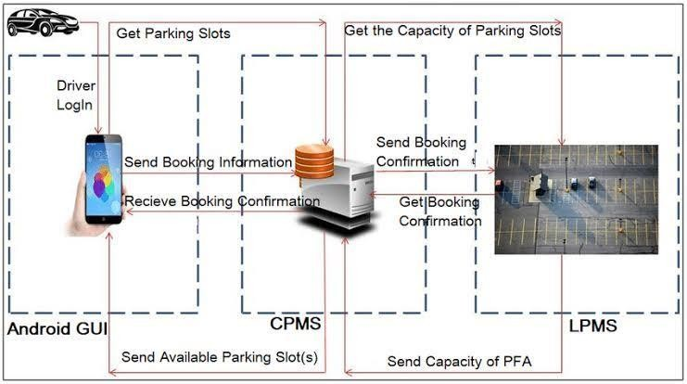

**Figure No. 3.3 System Architecture**

### CHAPTER 4

**SYSTEM SPECIFICATIONS**

The system specifications for an online vehicle parking system encompass a range of components and functionalities designed to optimize parking management. At its core are IoT devices, including sensors and cameras strategically placed in parking spaces to detect real-time occupancy. These devices communicate with a centralized server, either locally or through cloud-based platforms, where data is collected, processed, and securely stored. Users interact with the system via intuitive interfaces accessible through mobile applications or web browsers, enabling them to check availability, reserve parking spots, and conduct electronic payments seamlessly. A reservation system ensures spot availability upon arrival, while payment integration streamlines transactions. Robust security measures safeguard sensitive data, and analytics tools provide insights into usage patterns for informed decision-making. Scalability ensures adaptability to varying demands, while compatibility ensures accessibility across different devices and platforms. These specifications collectively form the backbone of a comprehensive IoT-based parking system, delivering efficiency, convenience, and enhanced user experiences.

### HARDWARE SPECIFICATIONS

* RAM: Minimum 8 GB RAM, recommended 16 GB RAM
* Processor: Dual core Processor
* Disk Space: Minimum 10 GB, recommended 20 GB (excluding system and project files)
* Screen Resolution: Minimum 1366 x 768

The hardware specifications for an online vehicle parking system are crucial for its successful implementation. Firstly, the system necessitates IoT devices such as sensors and cameras, strategically deployed in parking spaces to detect vehicle occupancy in real-time. These sensors need to be robust, weatherproof, and capable of wirelessly transmitting data to the central server. Additionally, a central server or cloud-based platform is essential for collecting, processing, and storing parking occupancy data securely. This server requires sufficient processing power, storage capacity, and network connectivity to handle the influx of data from multiple sensors simultaneously. Furthermore, reliable internet connectivity, whether through Wi-Fi, cellular, or Ethernet connections, is indispensable for seamless communication between IoT devices and the central server. Power sources, such as batteries or mains power, must also be considered to ensure uninterrupted operation of IoT devices. Overall, the hardware requirements play a critical role in the reliability, scalability, and performance of the IoT-based parking system.

### SOFTWARE SPECIFICATIONS

* OS: Windows 10/11 (64-bit), macOS 10.14 (Mojave) or later, Linux with GNU C Library (glibc) 2.31 or later
* IDLE: Python web
* Software: Compatible web browsers (e.g., Chrome, Firefox, Safari)
* Additional: Internet connectivity, GPS module for location services, IoT device compatibility for sensor integration OS: Windows 10/11 (64-bit), macOS 10.14 (Mojave) or later, Linux with GNU C Library (glibc) 2.31 or later
* IDLE: Python web
* Software: Compatible web browsers (e.g., Chrome, Firefox, Safari)
* Additional: Internet connectivity, GPS module for location services, IoT device compatibility for sensor integration

The software specifications for an online vehicle parking system using IoT encompass various components necessary for its development and operation. Firstly, a robust backend infrastructure is essential, typically implemented using programming languages like Python or Java to handle data processing, user authentication, and communication with IoT devices. Database management systems such as MySQL or MongoDB are required to store parking data securely and efficiently. Additionally, the frontend of the system necessitates web development technologies like HTML, CSS, and JavaScript for creating user interfaces accessible via web browsers or mobile apps. Integration with third-party APIs may be necessary for features like payment processing and notifications. Furthermore, software tools for IoT development, such as MQTT or HTTP protocols for communication between IoT devices and the central server, are crucial. Overall, the software requirements form the foundation for developing a comprehensive and functional online vehicle parking system using IoT, catering to both user interface and backend operations

### IOT COMPONENTS AND SENSORS NEEDED

In implementing an online vehicle parking system using IoT, a variety of IoT components and sensors are vital for accurate monitoring and efficient management of parking spaces. These include occupancy sensors placed in each parking spot to detect the presence or absence of vehicles in real-time. Additionally, cameras or image

sensors can provide visual confirmation of parking space occupancy and enhance security. Communication devices such as Wi-Fi or Bluetooth modules enable seamless data transmission between IoT devices and the central server. Power management systems, such as solar panels or battery packs, ensure uninterrupted operation of IoT devices. Moreover, environmental sensors can provide additional data, such as temperature or air quality, to enhance overall monitoring capabilities. By integrating these IoT components and sensors into the system, parking operators can effectively track parking space availability, optimize resource utilization, and improve the overall user experience.

### CHAPTER 5 ARCHITECTURAL DESIGN

### ARCHITECTURE

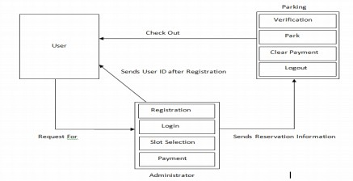

**Figure No. 5.1 Architecture**

The architecture design of an online vehicle parking system using IoT involves defining the structure and components of the system to ensure scalability, reliability, and efficiency.

### DATA FLOW DIAGRAM

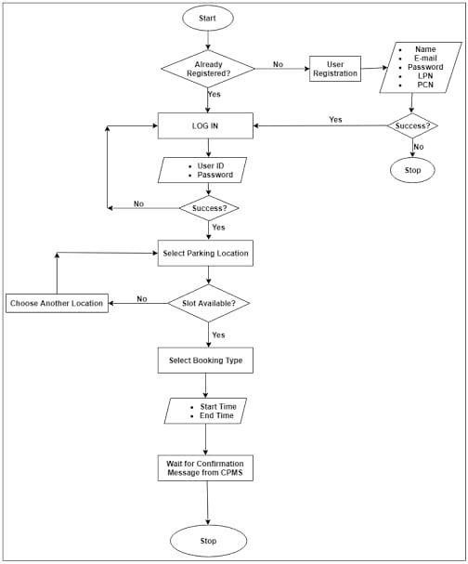

**Figure No.5.2 Data Flow Diagram**

### SYSTEM ARCHITECTURE OVERVIEW

The system architecture of an online vehicle parking system using IoT provides an overarching framework for its design and operation. At its core, this architecture employs a distributed model, where IoT devices, central servers, and user interfaces interact seamlessly to facilitate efficient parking management. The central server serves as the backbone of the system, orchestrating data processing, storage, and communication between various components. IoT devices, including sensors and cameras deployed in parking spaces, detect occupancy and transmit real-time data to the central server via communication protocols like MQTT or HTTP. User interfaces, accessible through mobile applications or web browsers, enable users to interact with the system, check parking availability, reserve spots, and make payments. Additionally, robust security measures, including encryption protocols and authentication mechanisms, safeguard sensitive data and ensure secure communication channels between system components. By following this system architecture overview, the online vehicle parking system using IoT can achieve scalability, reliability, and efficiency in managing parking spaces while delivering a seamless experience for users.

### IOT ARCHITECTURE COMPONENTS

The IoT architecture components of an online vehicle parking system play a crucial role in enabling seamless communication and data exchange between devices and the central server. These components encompass a range of hardware and software elements designed to facilitate efficient parking management. At the hardware level, IoT devices such as sensors and cameras are deployed in parking spaces to detect occupancy and transmit data to the central server. These devices are

equipped with communication modules, including Wi-Fi, Bluetooth, or LoRa, which enable wireless data transmission over local networks or the internet. Power management systems ensure uninterrupted operation of IoT devices, leveraging technologies like battery packs or solar panels to provide reliable power sources. On the software side, communication protocols such as MQTT (Message Queuing Telemetry Transport) or HTTP (Hypertext Transfer Protocol) are utilized to facilitate data exchange between IoT devices and the central server. These protocols ensure reliable and efficient communication, supporting real-time data transmission and message queuing for optimal system performance. By integrating these IoT architecture components, the online vehicle parking system can achieve seamless connectivity, accurate data collection, and efficient management of parking resources, ultimately enhancing the overall parking experience for users.

### COMMUNICATION PROTOCOLS

In an online vehicle parking system using IoT, communication protocols play a critical role in facilitating seamless data exchange between IoT devices and the central server. Two commonly used protocols for this purpose are MQTT (Message Queuing Telemetry Transport) and HTTP (Hypertext Transfer Protocol). MQTT is a lightweight and efficient protocol designed for low-bandwidth, high-latency networks, making it ideal for IoT applications. It utilizes a publish-subscribe architecture, where IoT devices publish data to specific topics, and the central server subscribes to these topics to receive updates in real-time. This approach minimizes network overhead and ensures timely delivery of data, making MQTT well-suited for real-time monitoring of parking space occupancy.

On the other hand, HTTP is a widely used protocol for communication over the internet. While it offers advantages such as simplicity and compatibility with existing web technologies, it may not be as efficient as MQTT for IoT applications due to its request-response model, which can introduce latency and overhead. However, HTTP can still be utilized in scenarios where real-time data transmission is not a strict requirement, such as user interactions with the system through web interfaces or mobile applications.

By leveraging communication protocols like MQTT and HTTP, the online vehicle parking system can establish reliable and efficient communication channels between IoT devices and the central server, enabling seamless data exchange and enhancing the overall functionality and performance of the system.

### CHAPTER 6 MODULE DESCRIPTION

* + - User management module
    - Parking slot management module
    - Payment processing module
    - Notification module

### USER MANAGEMENT MODULE

The user management module in an online vehicle parking system using IoT is responsible for handling user registration, authentication, and authorization processes. This module ensures secure access to the system's functionalities while providing a seamless user experience. Upon registration, users create accounts by providing necessary details such as name, email address, and password. The module validates user inputs, ensuring data accuracy and integrity. User authentication mechanisms, such as username-password authentication or two-factor authentication, verify the identity of users during the login process, safeguarding against unauthorized access.

Additionally, the user management module facilitates role-based access control (RBAC), allowing administrators to define user roles and permissions based on their responsibilities within the system. For example, parking operators may have access to functionalities related to managing parking spaces and viewing occupancy data, while regular users may only be able to reserve parking spots and make payments.

Furthermore, the module handles user profile management, enabling users to update their personal information, change passwords, or manage communication preferences. It also supports account recovery processes, such as password reset mechanisms, to assist users in case of forgotten credentials.

Overall, the user management module plays a crucial role in ensuring the security, accessibility, and usability of the online vehicle parking system, providing a foundation for user interactions and system functionality.

### PARKING SLOT MANAGEMENT MODULE

The parking slot management module in an online vehicle parking system using IoT is responsible for overseeing the allocation, reservation, and utilization of parking spaces. This module ensures efficient utilization of available parking slots while providing users with a seamless experience.At its core, the module maintains a real- time inventory of parking spaces, constantly updating the status of each slot based on occupancy data received from IoT sensors. When a user requests to reserve a parking spot through the system’s interface, the module checks the availability of the requested slot and processes the reservation if the spot is vacant.

Additionally, the module handles the release of reserved slots upon completion of the parking session or expiration of the reservation period. It also supports dynamic pricing strategies, allowing parking operators to adjust prices based on demand, time of day, or other factors.Furthermore, the parking slot management module generates insights and reports on parking usage patterns, such as peak hours, average occupancy

rates, and revenue generated. These insights enable parking operators to optimize slot allocation, improve resource utilization, and make data-driven decisions to enhance overall efficiency and profitability.

Overall, the parking slot management module serves as a central component of the online vehicle parking system, ensuring smooth operation, efficient allocation of parking resources, and a satisfactory experience for both users and parking operators.

### PAYMENT PROCESSING MODULE

The payment processing module in an online vehicle parking system using IoT is a critical component that facilitates secure and convenient electronic transactions for parking fees. This module enables users to make payments seamlessly through the system’s mobile app or web interface, eliminating the need for cash transactions and manual payment processing. Upon reserving a parking spot, users are prompted to enter their payment information, such as credit card details or digital wallets. The payment processing module securely encrypts this sensitive information and communicates it to the payment gateway for authorization. The payment gateway then verifies the transaction with the user’s bank or financial institution, ensuring the availability of funds and validating the payment request.

Once the payment is authorized, the system updates the reservation status and generates a confirmation receipt for the user. Simultaneously, parking operators

receive notifications of the successful transaction, allowing them to track revenue in real-time and manage parking resources effectively.

Robust security measures, including encryption protocols and compliance with Payment Card Industry Data Security Standard (PCI DSS) requirements, are implemented to safeguard users’ payment information and prevent unauthorized access or fraudulent activities. By integrating a secure and reliable payment processing module, the online vehicle parking system enhances user convenience, streamlines administrative processes, and ensures the integrity and confidentiality of financial transactions.

### NOTIFICATION MODULE

The notifications module in an online vehicle parking system using IoT plays a crucial role in keeping users informed about various aspects of the parking process. This module is responsible for generating and delivering notifications to users regarding parking availability, reservation confirmations, payment status, and other relevant updates. Notifications can be delivered through various channels, including email, SMS, or push notifications via the system’s mobile app.

When a user searches for parking availability, the system can send notifications in real-time, alerting them to nearby parking spots and their occupancy status. Upon successfully reserving a parking spot, the user receives a confirmation notification, along with details about the reserved spot and any applicable fees. Additionally, the system can send reminders to users nearing the end of their parking reservation period,

prompting them to extend their reservation if needed.Furthermore, the notifications module can provide updates on payment processing, informing users when their payment has been successfully processed and their reservation is confirmed. In cases where payment fails or there are issues with the reservation, the system can send notifications to alert users and provide instructions on resolving the issue.

By incorporating a robust notifications module into the online vehicle parking system, users can stay informed and up-to-date throughout the parking process, enhancing their overall experience and ensuring a smooth and seamless parking transaction.

**CHAPTER 7**

**CONCLUSION & FUTURE ENHANCEMENTS**

### CONCLUSION

The online vehicle parking reservation system represents a significant advancement in urban infrastructure, streamlining the process of finding and reserving parking spaces. This system enhances convenience for users by allowing them to secure parking spots in advance, reducing the time and stress associated with searching for parking. It also optimizes space utilization for parking facility operators, leading to increased revenue and improved traffic management. Additionally, by integrating real-time data and user-friendly interfaces, the system contributes to a more efficient and sustainable urban environment. Overall, the online parking reservation system exemplifies how technology can enhance everyday activities and urban living.

### FUTURE ENHANCEMENTS

Future enhancements for an online vehicle parking reservation system could include the integration of real-time data analytics and AI to optimize parking space utilization and provide predictive insights. Enhanced user experiences through mobile app improvements, such as augmented reality (AR) for finding parking spots, can also be envisioned. Additionally, incorporating IoT devices for automated entry and exit, and dynamic pricing models based on demand, could significantly improve efficiency and user satisfaction. Expanding payment options to include digital wallets and cryptocurrencies would cater to a broader audience. Further, partnerships with local

businesses for shared parking spaces during off-peak hours can increase availability and reduce congestion in urban areas. Finally, robust security features, including biometric authentication and advanced encryption, will ensure user data protection and system integrity.

### APPENDIX 1 SAMPLE CODE

Creating a comprehensive online vehicle parking reservation system involves multiple components, including a backend server, database, frontend application, and IoT integration. Below is a simplified version of the system using Python with Flask for the backend, SQLite for the database, and basic HTML for the frontend.

Backend (Flask)

1. Install Flask and SQLite: sh

pip install flask sqlite3

1. app.py (Backend Server): python

from flask import Flask, request, jsonify, render_template import sqlite3

app = Flask( name )

def init_db():

conn = sqlite3.connect('parking.db') cursor = conn.cursor() cursor.execute

('''

CREATE TABLE IF NOT EXISTS slots ( id INTEGER PRIMARY KEY,

slot_number TEXT NOT NULL, is_reserved INTEGER DEFAULT 0

)

''')

conn.commit() conn.close() app.route('/') def index():

return render_template('index.html') app.route('/slots', methods=['GET']) def get_slots():

conn = sqlite3.connect('parking.db') cursor = conn.cursor() cursor.execute('SELECT * FROM slots') slots = cursor.fetchall()

conn.close()

return jsonify(slots)

app.route('/reserve', methods=['POST']) def reserve_slot():

slot_id = request.form['slot_id'] conn = sqlite3.connect('parking.db') cursor = conn.cursor()

cursor.execute('UPDATE slots SET is_reserved = 1 WHERE id = ?', (slot_id,)) conn.commit()

conn.close()

return 'Reservation successful', 200 app.route('/cancel', methods=['POST']) def cancel_reservation():

slot_id = request.form['slot_id'] conn = sqlite3.connect('parking.db') cursor = conn.cursor()

cursor.execute('UPDATE slots SET is_reserved = 0 WHERE id = ?', (slot_id,)) conn.commit()

conn.close()

return 'Reservation cancelled', 200 if name == ' main ':

init_db() app.run(debug=True)

Frontend (HTML)

1. templates/index.html: html

<!DOCTYPE html>

<html lang="en">

<head>

<meta charset="UTF-8">

<meta name="viewport" content="width=device-width, initial-scale=1.0">

<title>Parking Reservation System</title>

</head>

<body>

<h1>Parking Reservation System</h1>

<div id="slots"></div>

<script>

async function fetchSlots() {

const response = await fetch('/slots'); const slots = await response.json();

const slotsDiv = document.getElementById('slots'); slotsDiv.innerHTML = slots.map(slot => `

<div>

Slot ${slot[1]} - ${slot[2] ? 'Reserved' : 'Available'}

<button onclick="reserveSlot(${slot[0]})" ${slot[2] ? 'disabled' : ''}>Reserve</button>

<button onclick="cancelReservation(${slot[0]})" ${!slot[2] ? 'disabled'

: ''}>Cancel</button>

</div>

`).join('');

}

async function reserveSlot(slotId) { await fetch('/reserve', {

method: 'POST', headers: {

'Content-Type': 'application/x-www-form-urlencoded',

},

body: `slot_id=${slotId}`,

});

fetchSlots();

}

async function cancelReservation(slotId) { await fetch('/cancel', {

method: 'POST', headers: {

'Content-Type': 'application/x-www-form-urlencoded',

},

body: `slot_id=${slotId}`,

});

fetchSlots();

}

fetchSlots();

</script>

</body>

</html>

Database Initialization

Make sure to run the init_db function once to create the database and table. You can add initial data to the slots table directly in the SQLite database using a SQLite browser or by adding more code to the init_db function.

Running the Application

Run the Flask application by executing:

sh

python app.py

This simple implementation provides a basic parking reservation system with functionalities to view parking slots, reserve a slot, and cancel a reservation. In a real- world scenario, you would also need to add user authentication, more detailed error handling, and a more sophisticated frontend.

### APPENDIX 2 PARKING AREA

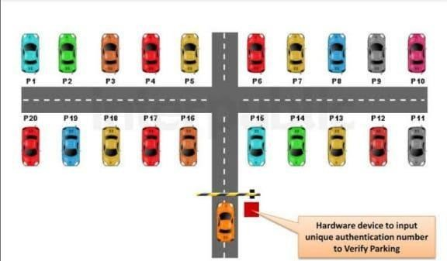

**Figure No. A.2.1 Base View of Vehicle Reserved Parking**

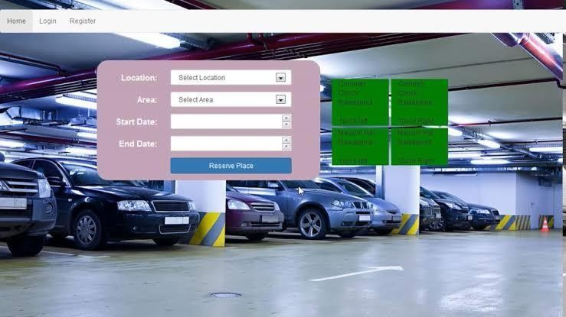

**Figure No.A.2.2 Vehicle Parking Reservation Site**

### REFERENCES:

1. Chen, H. (2020). Development and Deployment of Online Parking Reservation Systems. Park Easy Inc.
2. Garcia, M. (2022). Sustainable Urban Mobility and the Role of Smart Parking Systems. Institute of Transport Studies, University of Leeds.
3. Johnson, L. (2019). Smart Parking Solutions in Modern Cities. Massachusetts Institute of Technology, Urban Mobility Lab.
4. Kumar, R. (2021). Intelligent Parking Systems: Innovations and Implementations. University of California, Berkeley.
5. Smith, A. (2018). The Future of Parking: Online Reservation Systems. Frost & Sullivan.